Azure Honeypot Threat Detection & Response Project
Author: Alexis Fausto
Date: 2/14/25

- Executive Summary
This report documents the design, deployment, and analysis of a cloud-based honeypot environment hosted in Microsoft Azure. The objective was to expose a Windows 10 virtual machine (VM) to the public internet to attract real-world malicious activity—primarily automated RDP brute-force attacks—to evaluate how cloud-native security tools detect, enrich, and visualize threat data.
Azure Sentinel, Log Analytics, and Kusto Query Language (KQL) were leveraged to collect telemetry, enrich IP data with geographic context, create analytic queries, and develop interactive visualizations such as a global “Attack Map.” These components were orchestrated to simulate an end-to-end Security Operations Center (SOC) workflow, including data ingestion, detection engineering, threat hunting, and reporting.
The findings demonstrate how rapidly internet-exposed services are targeted, highlight attacker behavioral patterns, and reinforce the importance of layered security controls. This project shows practical SOC capabilities such as detection logic development, log enrichment, incident triage, and Azure security architecture.

- Project Scope
In Scope
- Deployment of a Windows 10 Azure VM configured as a honeypot
- Exposure of RDP to the internet to attract brute-force attempts
- Collection and analysis of security logs (Event ID 4625)
- Sentinel onboarding, enrichment, watchlist creation, and dashboard development
- Threat hunting and visualization using KQL and Sentinel Workbooks
- Documentation of results, analysis, and remediation recommendations
Out of Scope
- Malware detonation or full compromise simulation
- Red team operations or controlled adversary emulation
- Production-level hardening, EDR tuning, or incident response playbooks
- Multi-cloud or hybrid environment integrations
Limitations
- VM was intentionally misconfigured (insecure) for controlled research only
- Data collection timeframe limited results to observed automated attacks
- No user accounts or sensitive assets were present
- Windows 10 used for lab simplicity, not enterprise hardening standards

  - Objectives
- Deploy a Windows 10 VM in Azure and convert it into a safe, cloud-based honeypot.
- Generate authentication failure telemetry (Event ID 4625) for analysis.
- Configure Azure Monitor Agent (AMA) and a Data Collection Rule (DCR) to forward logs into a Log Analytics Workspace (LAW).
- Enable Azure Sentinel as the SIEM platform.
- Enrich incoming data with GeoIP information using a Sentinel Watchlist.
- Build an interactive Attack Map using a Sentinel Workbook to visualize attacker locations.
- Perform analysis, interpret results, and document recommendations.

  - Business / SOC Use Case
Organizations deploy honeypots to:
- Monitor and analyze how real-world attackers operate by recreating their tactics and techniques within a secure, controlled testing environment
- Improve threat intelligence and detection logic
- Capture brute-force attempts and credential attacks targeting exposed services
- Train SOC analysts using safe, high-quality malicious telemetry
This project replicates those objectives by simulating an enterprise detection pipeline entirely within Azure.

  - Environment & Tools Used
Azure Services
- Azure Virtual Machine (Windows 10)
- Network Security Group (NSG)
- Azure Monitor Agent (AMA)
- Data Collection Rules (DCR)
- Log Analytics Workspace (LAW)
- Azure Sentinel (SIEM)
- Sentinel Watchlists
- Sentinel Workbooks (Attack Map)
Security / Analysis Tools
- Windows Event Viewer
- Kusto Query Language (KQL)
- GeoIP CSV database
- Azure Maps visualization
- MITRE ATT&CK Framework

  - Architecture Overview

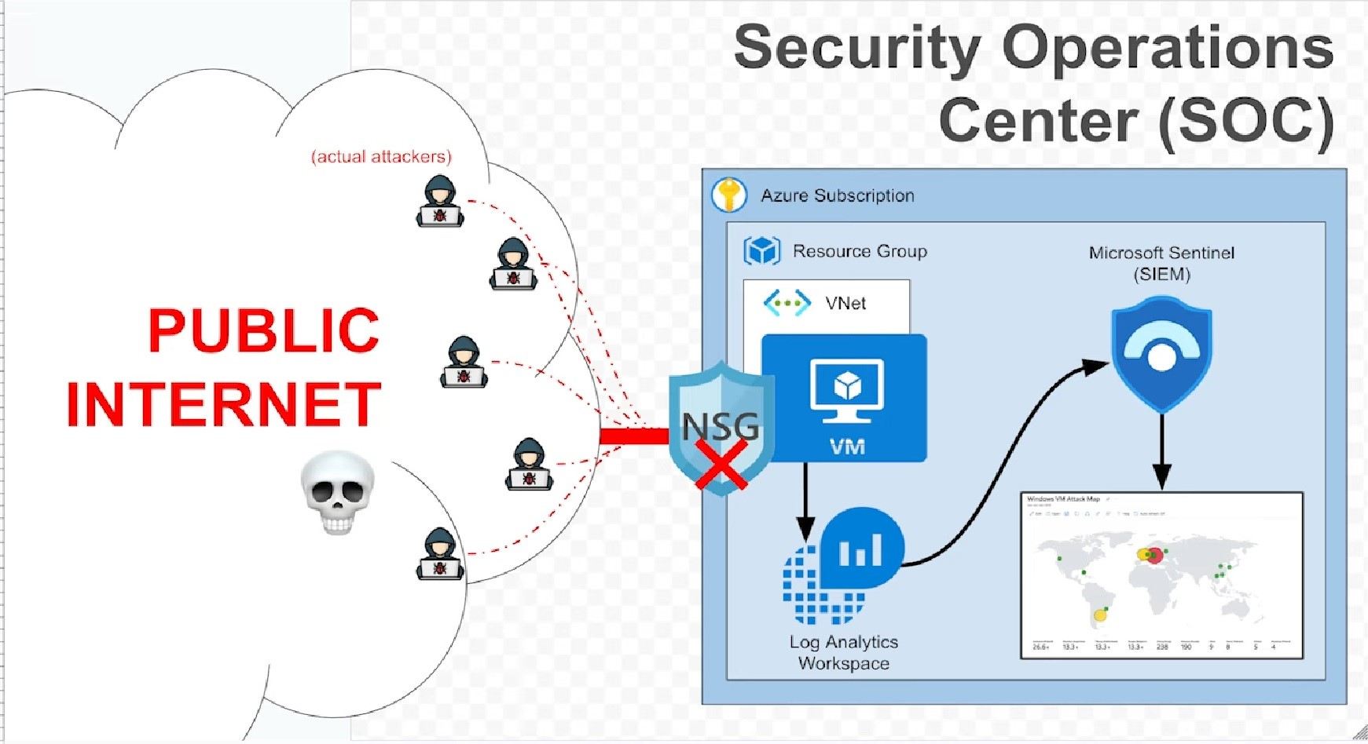

7. Build Process
7.1 Honeypot VM Deployment
A Windows 10 VM was deployed and intentionally configured with:
- Public IP Address
- NSG rule allowing all inbound traffic
- Windows Firewall disabled (lab-only)
- The objective is to intentionally configure the virtual machine so that it is easily identifiable and discoverable by common internet-wide automated scanners and botnet reconnaissance tools.

7.2 Generating Authentication Failures
Multiple failed RDP login attempts were executed using invalid credentials.
On the VM, Event Viewer confirmed the creation of relevant failed authentication events
Captured telemetry included:
- Username attempted
- Source IP
- Logon type
- Timestamp
- Failure reason

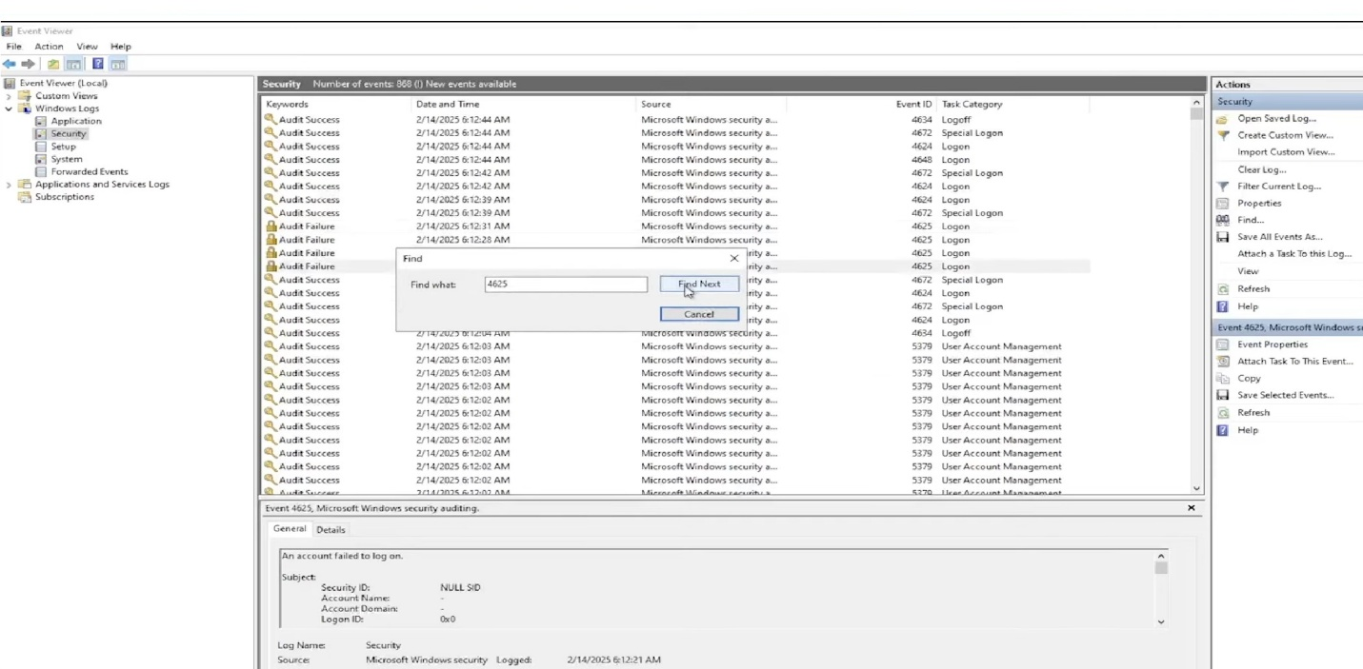

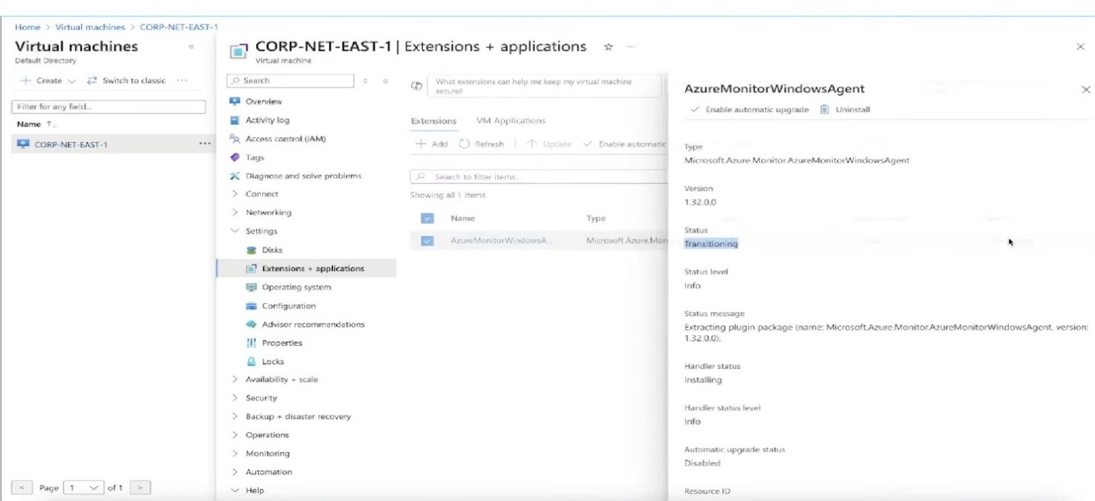
7.3 Centralized Logging with LAW & Sentinel

- The Azure Monitoring Agent collects and securely forwards system and security telemetry—such as event logs, performance metrics, and audit data—from the virtual machine to our centralized Log Analytics Workspace, enabling advanced analysis, correlation, and automated threat detection through Microsoft Sentinel.

- A dedicated Log Analytics Workspace was provisioned to serve as the centralized repository for log and telemetry data, and Microsoft Sentinel was subsequently onboarded and connected to this workspace to enable advanced security analytics, threat detection, and incident response capabilities.
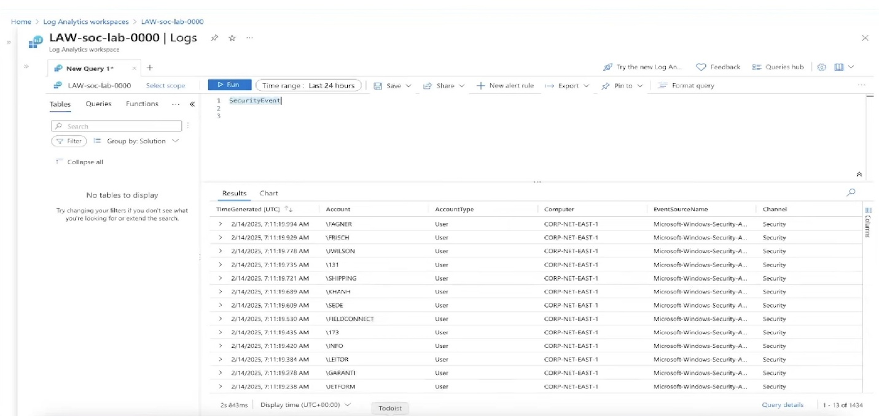
SIEM Enablement
Microsoft Sentinel was onboarded and connected to LAW to enable:
- Correlation
- Alerting
- Threat detection
- Workbook visualization
DCR Configuration
A Data Collection Rule was configured to continuously forward Windows Security logs, enabling real-time monitoring.

Verification KQL
SecurityEvent
| where EventID == 4625
| sort by TimeGenerated desc

7.4Data Enrichment Using GeoIP Watchlist
- In this section, a CSV file was imported into Microsoft Sentinel to create a Watchlist, which automatically generated a custom table within Log Analytics. This table serves as a reference dataset that can be used in KQL queries for correlation, enrichment, and advanced threat detection across ingested security logs.

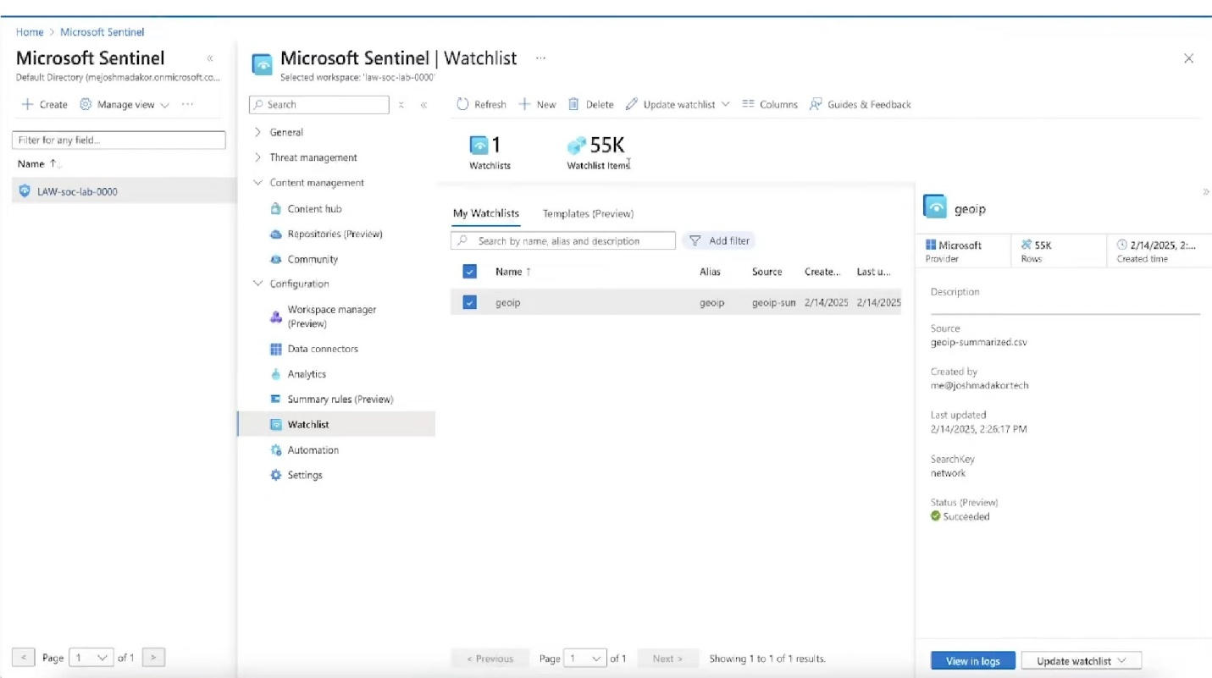

- A comprehensive GeoIP dataset, consisting of 54,000 IP network blocks with associated geographic metadata (including country, region, city, and coordinates), was imported into Azure Sentinel as a watchlist named ‘geoip’ to enable enrichment of incoming security events and support detailed attacker location analysis.

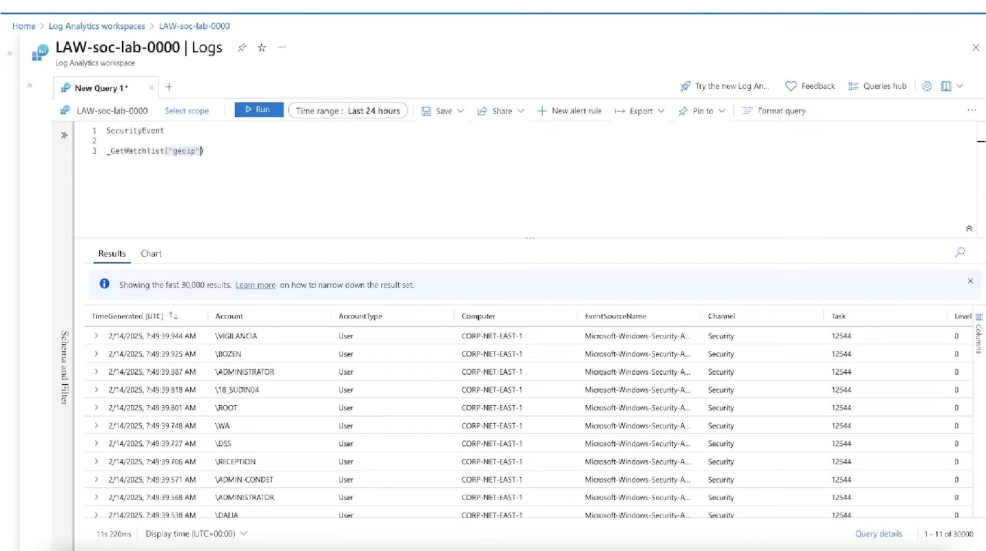

Enrichment applied using ipv4_lookup:
let GeoIPDB = _GetWatchlist("geoip");
SecurityEvent
| where EventID == 4625
| where IpAddress <> ""
| evaluate ipv4_lookup(GeoIPDB, IpAddress, network)
| project TimeGenerated, Account, IpAddress, country, region, city

  - Attack Map Workbook

- I demonstrated proficiency in data visualization by creating a new workbook through advanced JSON configuration. I defined key parameters such as geographical location, aggregation metrics, and visual styling including heatmap color palettes to effectively represent failure counts across countries. This approach showcases my ability to customize complex data queries and enhance insights through precise, data-driven visual representation.

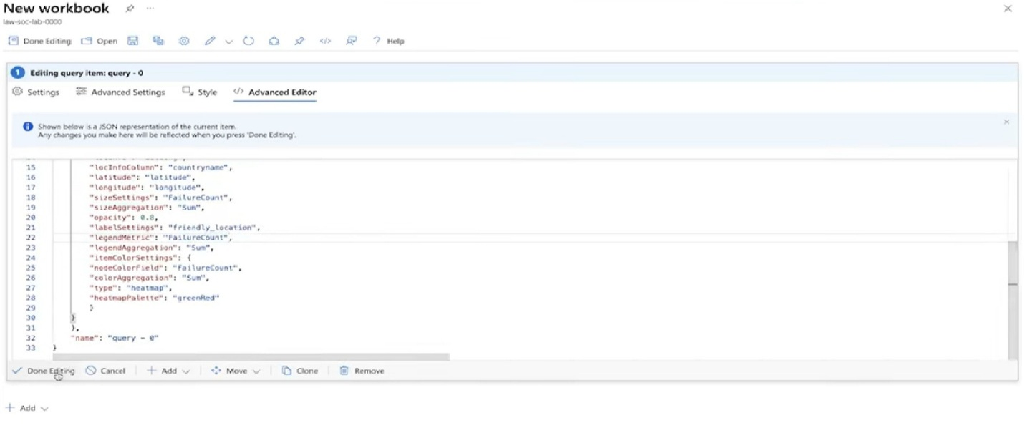
A custom Sentinel Workbook was created using JSON-based configuration to:
- Plot geo-coordinates
- Aggregate attack counts
- Scale pins dynamically
- Apply map controls for geospatial analysis
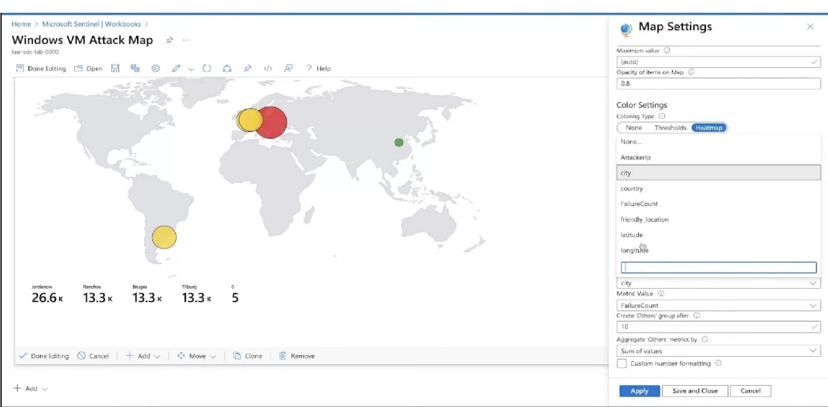

Query powering the map:
let GeoIPDB = _GetWatchlist("geoip");
SecurityEvent
| where EventID == 4625
| where IpAddress <> ""
| summarize attempts = count() by IpAddress
| evaluate ipv4_lookup(GeoIPDB, IpAddress, network)
| project IpAddress, attempts, country, region, city, latitude, longitude
Azure Maps was used to display pins scaled by attack frequency.

Results & Analysis
1. Time to First Attack
- Automated RDP brute-force attempts began within 24 hours of exposure, confirming rapid discovery by global scanning infrastructure.

2. Total Failed Login Attempts Collected
- Over 6,249 failed RDP login attempts were recorded in the first 24 hours.
3. Top Attacker Countries
- Poland
- Belgium
- China
- Brazil

4 . Notable Observations
- Many attacks originated from cloud providers (DigitalOcean, OVH, AWS).
- Several IP addresses produced high-volume bursts indicative of automated tools.
- Enriched geographic data revealed clustering of attack origins.

9. MITRE ATT&CK Mapping
Event | MITRE Technique | Description
RDP Brute-Force Attempts | T1110 – Brute Force | Automated password-guessing attacks
Remote Authentication via RDP | T1021 – Remote Services | Attempts to access systems via RDP
Attempt to Gain Unauthorized Access | T1078 – Valid Accounts | Adversaries attempting to use credentials
Including MITRE alignment demonstrates understanding of SOC analysis frameworks.

10. Key KQL Queries
A. Failed Logins
SecurityEvent
| where EventID == 4625

B. Enriched IP Data
let GeoIPDB = _GetWatchlist("geoip");
SecurityEvent
| where EventID == 4625
| evaluate ipv4_lookup(GeoIPDB, IpAddress, network)
C. Top Attacker IPs
let GeoIPDB = _GetWatchlist("geoip");
SecurityEvent
| where EventID == 4625
| summarize attempts = count() by IpAddress
| order by attempts desc

11. Security Recommendations
Recommendation | Severity | Expected Impact | Difficulty
Restrict RDP to approved IP ranges or use Azure Bastion | High | Reduces attack surface | Medium
Enforce MFA and strong password policies | High | Mitigates brute-force attempts | Low
Deploy Microsoft Defender for Endpoint (EDR) | High | Provides deeper forensics & automated response | Medium
Create Sentinel Analytics Rules | Medium | Improves detection coverage | Medium
Implement automated IP blocking via Logic Apps | Medium | Rapid response to brute-force sources | Medium

12. Lessons Learned
- Hands-on experience with Azure cloud security architecture
- SIEM log ingestion, correlation, and threat hunting using KQL
- Data enrichment using watchlists and ipv4_lookup
- Visualization and reporting through custom workbooks
- Understanding how attackers discover and target exposed services
- Experience designing a mini-SOC workflow end-to-end

13. Conclusion
This project successfully simulated a cloud-based attack surface, captured real attacker activity, and used Azure Sentinel to analyze and visualize brute-force attempts. It demonstrated practical experience in cloud security monitoring, threat detection, log analytics, and incident analysis—key competencies for cybersecurity and SOC analyst positions. I learned a lot using all these tools and methods. I plan to continue to expand my learning endeavors within cyber security with programs such as Microsoft Azure and others.

